**附：系列讲座安排信息：**

|  |  |  |  |  |
| --- | --- | --- | --- | --- |
| **系列** | **主题** | **主讲人** | **时间** | **地点** |
| 1. | Travelling | Andrew Olivi | 2014年3月13日，18:40—20:00 | 南湖：文波209 |
| 2014年3月20日，18:40—20:00 | 首义：文津311 |
| 2. | Art | Julie Napientek | 2014年4月10日，18:40—20:00 | 南湖：文波209 |
| 2014年4月17日，18:40—20:00 | 首义：文津311 |
| 3. | Personal Courage in a Changing China | Kevin Gladney | 2014年5月15日，18:40—20:00 | 南湖：文波209 |
| 2014年5月22日，18:40—20:00 | 首义：文津311 |
| 4. | US Culture: The American Dream in the 21st Century | Eric Giboney | 2014年6月12日，18:40—20:00 | 南湖：文波209 |
| 2014年6月19日，18:40—20:00 | 首义：文津311 |

**Lecture 1:** Travelling

**Lecturer:** Andrew Olivi

**Time:** 6:40-8:00 pm, March 13, 2014

**Place: Wenbo 209 Nanhu Campus**

**Time:** 6:40-8:00 pm, March 20, 2014

**Place**：**Wenjin 311 Shouyi Campus**

**Abstract:** When you travel the world is your classroom. So it is obvious that there is much to learn from the experiences encountered while travelling. However, before having a positive travelling adventure, there are many things that must be considered. This lecture will address the preparations to be made before travelling, ways to save money while travelling, and some uncommon but unique travelling methods.

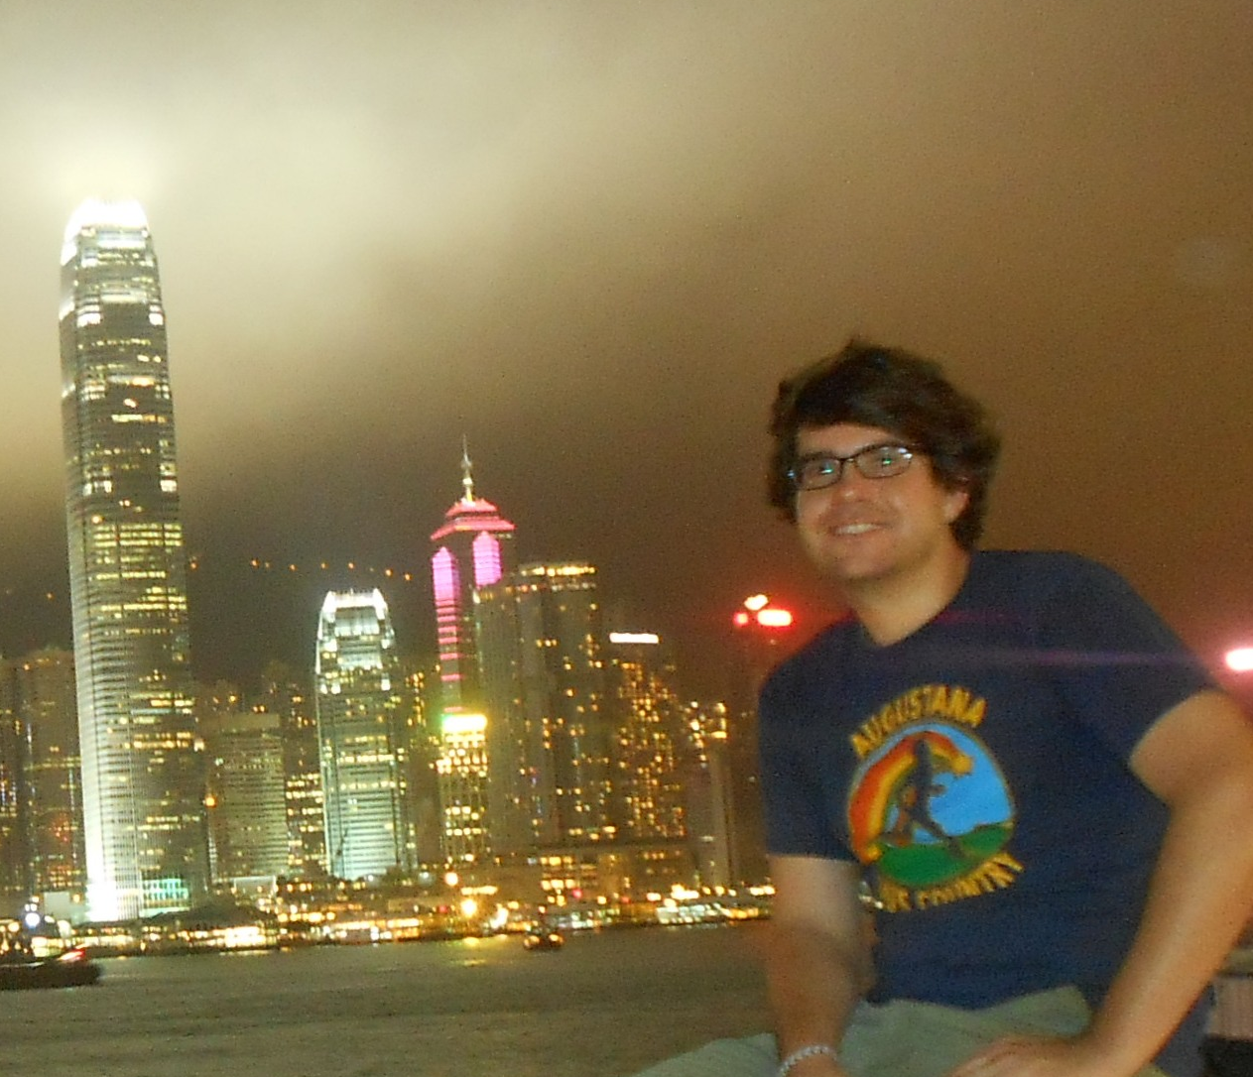

**Biographical Information:** Raised in the South-side of Chicago, Andrew Olivi is not your typical urbanite. After studying geology, geography, and environmental science at Augustana College, he went on to travel East and Southeast Asia with a base camp in China as an English teacher. This is Andrew’s fifth year living in China and there are no signs of a slowdown in his perpetual rambling lifestyle.

**Lecture 2:** Art

**Lecturer:** Julie Napientek

**Time:** 6:40-8:00 pm, April 10, 2014

**Place: Wenbo 209 Nanhu Campus**

**Time:** 6:40-8:00 pm, April 17, 2014

**Place**：**Wenjin 311 Shouyi Campus**



**Abstract:** This lecture will provide a survey of Western art, in particular by examining the way that style and subject matter in art have changed and evolved over time. Additional consideration will be placed on how the definition of what constitutes as fine art has been expanded and modified throughout the centuries.

**Biographical Information:** Julie Napientek is an English teacher from Chicago, Illinois. She attended Augustana College in Rock Island, Illinois and graduated with a double major in anthropology and art history. She has traveled abroad to several different countries before, though this is her first time in China. She hopes her lecture will prove informative and stimulate and interest in art.

**Lecture 3:** Personal Courage in a Changing China

**Lecturer:** Kevin Gladney

**Time:** 6:40-8:00 pm, May 15, 2014

**Place: Wenbo 209 Nanhu Campus**

**Time:** 6:40-8:00 pm, May 22, 2014

**Place**：**Wenjin 311** **Shouyi Campus**

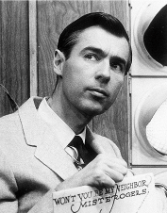

**Abstract:** This lecture will focus on the importance of personal courage in the developing Chinese social landscape. As China modernizes and many malevolent social forces arise within the culture, Chinese citizens, especially young students, must develop the physical and moral fortitude necessary to confront these problems head-on. We will explore the roots of these problems and look for possible ways forward.

**Biographical Information：**

 Kevin Gladney is an instructor of English majors at Zhongnan University. He holds a Bachelor’s degree in English from the University of Georgia and a Master’s in Medieval English Literature from the Medieval Institute at Western Michigan University. In his spare time, Kevin enjoys cetology and high-altitude skydiving.

**Lecture 4:** US Culture: The American Dream in the 21st Century

**Lecturer:** Eric Giboney

**Time:** 6:40-8:00 pm, June 12, 2014

**Place: Wenbo 209 Nanhu Campus**

**Time:** 6:40-8:00 pm, June 19, 2014

**Place**：**Wenjin 311** **Shouyi Campus**



**Abstract:** The rising affluence in America during the 1900s brought a common dream to modern Americans. The dream for a good job, material possessions, and a comfortable life has driven many to work hard in pursuit of this success. But how realistic is the American Dream in the 21st century?

**Biographical Information：**

Eric Giboney is from Kansas City, Missouri in the United States. He has taught at ZNUEL since 2011 and is very grateful for the opportunity to experience life in China. He loves examining culture and popular thought, and is constantly searching for a deeper understanding of truth.